Individual Pathways
Activity 7.3

Investigating chemical reactions further

- Water decomposes to oxygen gas and hydrogen gas. If you had 36 grams of water and produced 32 grams of oxygen, how much hydrogen would be produced?
- 36 g
- 32 g
- 18 g
- 4 g

- When an exothermic reaction takes place, the reaction mixture gets hotter because
- in an exothermic change the products contain more ‘stored’ energy than the reactants.
- energy is always released in a chemical change that makes new substances.
- exothermic changes always produce gases.
- more energy is released when new bonds are formed than is needed to break the bonds in the reactants.

- Change 1: When calcium carbonate forms calcium oxide and carbon dioxide heat is absorbed.
Change 2: Calcium oxide releases heat when shaken with carbon dioxide.
Which best describes these changes?
- Change 1 is exothermic, change 2 is endothermic.
- Both change 1 and 2 are exothermic.
- Both change 1 and 2 are endothermic.
- Change 1 is endothermic, change 2 is exothermic.

- Sodium hydroxide is a strong base commonly found in cleaning agents. Which of the following solutions could be used to safely neutralise a sodium hydroxide chemical spill?
- Ammonia — pH = 8
- Citric acid — pH = 4
- Potassium hydroxide — pH = 11
- Water — pH = 7

Questions 5–7 refer to the following information.
A student has 10 mL of acid solution in a beaker and wishes to convert it to a neutral solution by adding the correct amount of a suitable second solution.

- The type of solution the student would have to add is
- an acidic one that is weaker than the original.
- an acidic one that is stronger than the original.
- one that has basic properties.
- any solution containing a salt.

- When the exact amount of the second solution has been added to neutralise the original and the solutions are mixed well
- the resulting mixture has neither acidic nor basic properties.
- a chemical salt would be formed.
- a small amount of water would be formed.
- all of the above would be true.

- If the student accidentally added too much of the second solution, then the resulting mixture would
- form more chemical salt than when the exact amounts were mixed.
- be basic.
- be only faintly acidic.
- produce no chemical salt at all.

- In chemical reactions, mass is neither gained nor lost. The total mass of all the reactants equals the total mass of all the products and atoms are just rearranged into different substances. Use this information to complete the following questions.
- Decomposition of calcium carbonate produces calcium oxide and carbon dioxide gas.
How much carbon dioxide is produced from the decomposition of 200 g of calcium carbonate if 112 g of calcium oxide is produced?
........................................................................................................................................................
- Combustion of octane in a car engine produces carbon dioxide and water vapour.
If 57 g of octane reacts with 200 g of oxygen, producing 176 g of carbon dioxide, how many grams of water vapour are produced?
........................................................................................................................................................

- To light a match you must strike it against the side of a matchbox.
- Is the burning of the match an endothermic or exothermic reaction and how do you know?
- Why is it necessary to provide energy by striking the match before the chemical reaction of burning takes place?

- Complete the following word equations.
- magnesium carbonate + hydrochloric acid → _______________________ + _________ + ______________________
- sodium hydroxide + _____________________ → sodium sulfate + __________
- __________________________ + nitric acid → calcium ____________ + water + carbon dioxide
- __________________________ + ________________________ → zinc chloride + water
- ___________ + _____________________ → zinc chloride + hydrogen
- combustion of kerosene: ______________ + _________________ → ________________________ + __________
- Which of the reactions (a)–(f) is involved in the damage to buildings and statues?

- Three indicators were used to test some liquids labelled X, Y and Z to determine the level of their acidity. The colours of the indicators and the results of the experiments are shown in the following tables.

Indicator | Information on colour and pH
Thymol blue | pH<1.2 (red)  pH 1.2–2.8 (orange)  pH>2.8 (yellow)
Bromophenol blue | pH<3.0 (yellow)  pH 3.0–4.6 (green)  pH>4.6 (blue)
Methyl red | pH<4.4 (pink)  pH 4.4–6.2 (orange)  pH>6.2 (yellow)

Indicator | X | Y | Z
Thymol blue | Yellow | Orange | Yellow
Bromophenol blue | Green | Yellow | Blue
Methyl red | Orange | Pink | Orange

- For each substance, determine the approximate pH range of each unknown liquid. Explain your reasoning.
X:..........................................................................................................................................................................................................................................................................................................
Y:.......................................................................................................................................................................................................................................................................................................... Z:..........................................................................................................................................................................................................................................................................................................

- List the liquids X, Y and Z in order from most acidic to least acidic.
........................................................................................................................................................

- Natalie and Megan added some sodium hydroxide drop by drop to some hydrochloric acid in a test tube and used a pH meter to follow what happened to the pH of their solution. Their results are shown in the graph below.

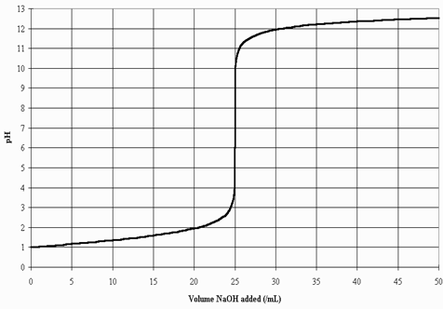

- Explain why the pH of the solution kept going up.
………………………………………………………………………………………………………..
- Write a word equation for this reaction.
………………………………………………………………………………………………………..
- At how many drops would you say the acid was neutralised? Justify your answer.
………………………………………………………………………………………………………..
………………………………………………………………………………………………………..
- If the students stopped adding the sodium hydroxide as soon as the solution was neutral and allowed the water to evaporate, what would be left in the test tube?
………………………………………………………………………………………………………..

- Write clues for the following chemical reactions crossword.

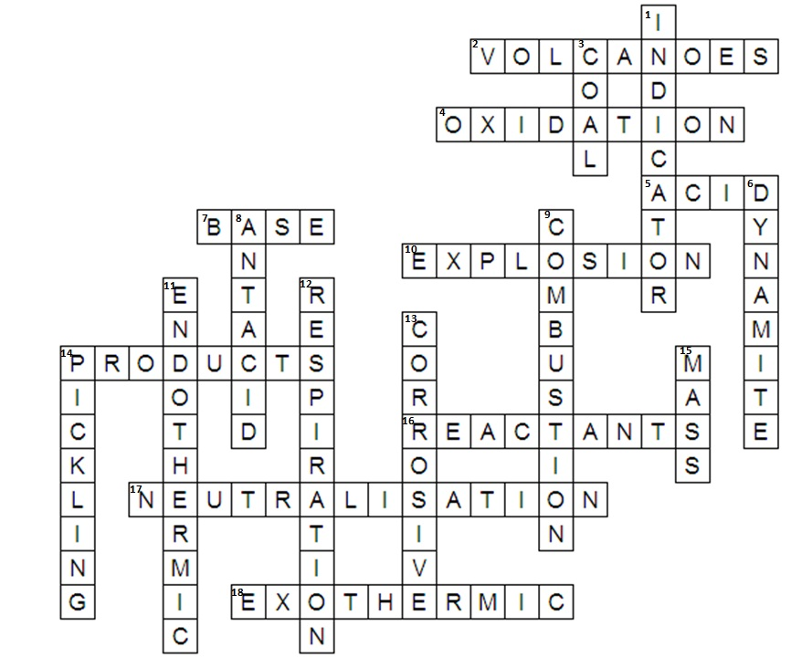

ACROSS | DOWN
2 | 1
4 | 3
5 | 6
7 | 8
10 | 9
14 | 11
16 | 12
17 | 13
18 | 14
 | 15

